**PORTFOLIO PROJECT**

Submitted by

**S. NITHRUJA**

**Reg.No :1P21MC034**

In partial fulfilment of the requirement for the award of the Degree of

**Master of Computer Applications**

**Bharathiar University**

**Coimbatore**.

Under the Internal Supervision of

**Dr. S Ranjitha Kumari M.sc.,M.Phil.,Ph.D**

**Associate Professor**

**School of Computer Studies-MCA**



**Master of Computer Applications,**

**Rathnavel Subramaniam College of Arts and Science (Autonomous),**

**Sulur, Coimbatore – 641 402**

**February 2022**

**RATHNAVEL SUBRAMANIAM COLLEGE OF ARTS AND SCIENCE**

**(AUTONOMOUS)**

**AFFLIATED TO BHARATHIAR UNIVERSITY**

**NAAC Re-accredited & ISO 9000:2008 Certified**

**SULUR, COIMBATORE-641402.**



**February 2022**

**Register Number – 1P21MC034**

Certified bona fide original record of work done by S. NITHRUJA

**Internal Supervisor HOD**

Submitted for the project Evaluation and Viva voice held on**………………….**

**Internal Examiner External Examiner**

**Index**

|  |  |  |
| --- | --- | --- |
| S.NO | CHAPTERS | PAGE NO |
| 1 | Chapter 1:  Vedio introduction  1.1 YouTube vedio | 2 |
| 2 | Chapter 2  Website bio score  2.1 about me  2.2 resume  2.3 resume page  2.4 contact page  2.5 footer page  2.6 script | 5 |
| 3 | Chapter 3  Page and navigation  3.1 landing page  3.2 project page | 15 |
| 4 | Chapter 4  Styles link  4.1 styles (font color image)  4.2 styles | 23 |
| 5 | Chapter 5  Website include the following information  5.1 project links to github  5.2 project description | 24 |
| 6 | Chapter 6  Bootstrap  6.1 use bootstrap | 25 |
| 7 | Chapter 7  Project readme  7.1 title description | 26 |
| 8 | Chapter 8  File structure  8.1 github structure | 31 |

**PORTFOLIO PROJECT**

**CHAPTER 1:**

**VEDIO INTRODUCTION**

* 1. Youtube video:

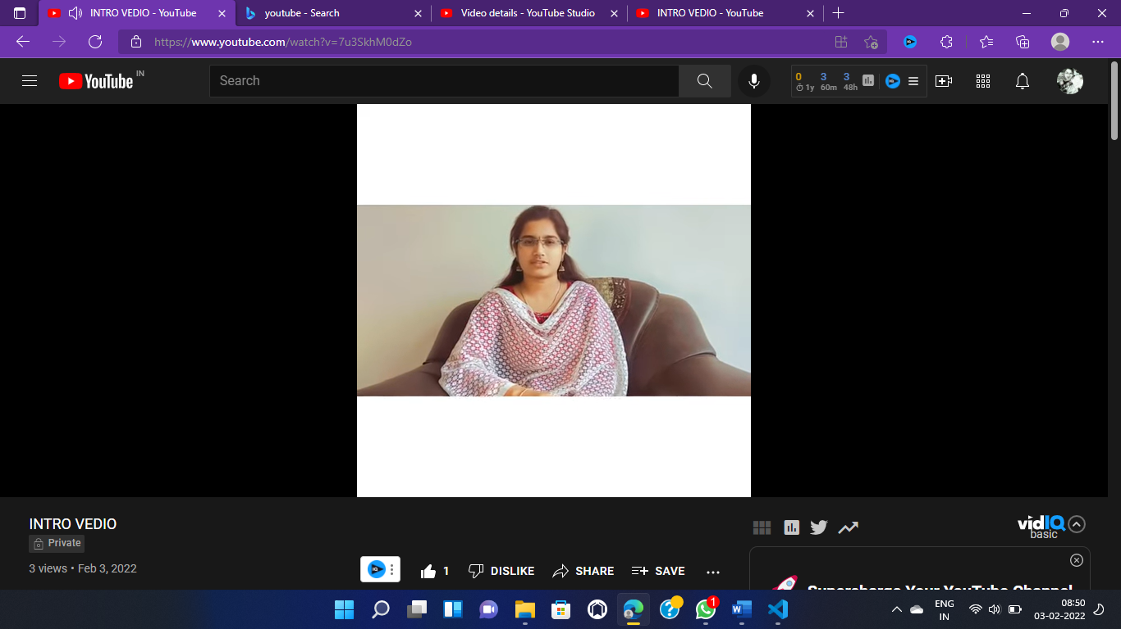

YOUTUBE LINK:

<https://www.youtube.com/watch?v=gCySFlzfLlU&feature=youtu.be>

**CHAPTER 2**

**WEBSITE BIO SCORE:**

**2.1 About me**

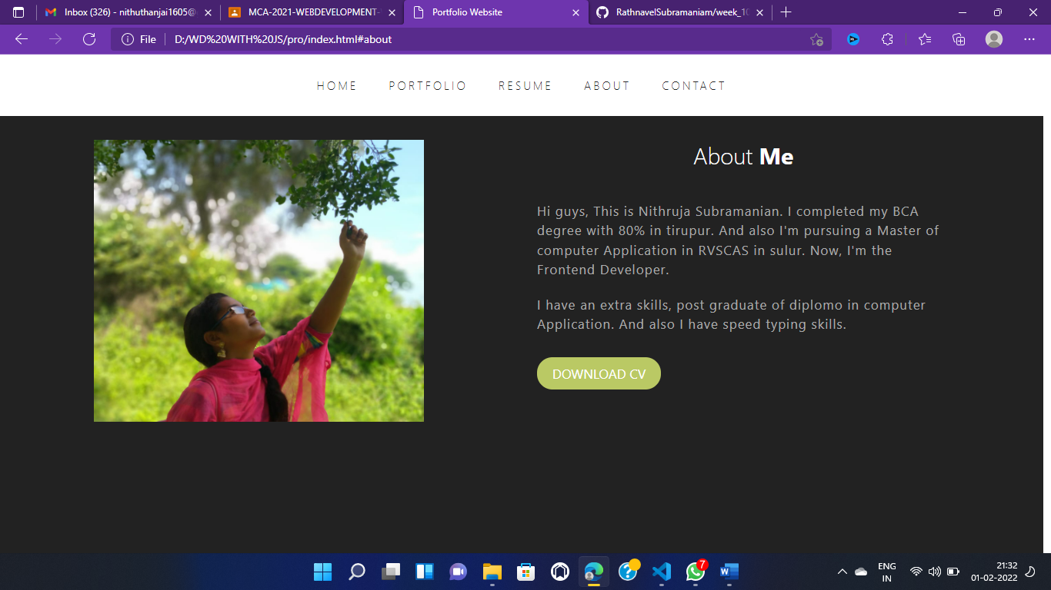

HTML FILE:

 <!-- about section starts -->

<section class="about" id="about">

    <div class="box-container">

      <div class="box">

        <div class="image">

          <img src="images/5.jpeg" alt="" />

        </div>

      </div>

      <div class="box">

        <h1 class="heading">about <span>me</span></h1>

        <p>

          Hi guys, This is  Nithruja Subramanian. I completed my BCA degree with 80% in tirupur.

          And also I'm pursuing a Master of computer Application in RVSCAS in sulur.

          Now, I'm the Frontend Developer.

        </p>

        <p>

          I have an extra skills, post graduate of diplomo in computer Application.

          And also I have speed typing skills.

        </p>

        <a href="https://drive.google.com/file/d/1T-Ww4xiSDmjMJxjN8UlKlwqke1_gPtiP/view" class="btn">download cv</a>

      </div>

    </div>

  </section>

  <!-- about section ends -->

CSS:

/* about */

.about .box-container .box .image {

    height: 80%;

    overflow: hidden;

  }

  .about .box-container .box .image img {

    width: 80%;

    height: 80%;

    object-fit: cover;

  }

  .about .box-container {

    display: grid;

    grid-template-columns: repeat(auto-fit, minmax(30rem, 1fr));

    gap: 4rem;

  }

  .about .box-container .box p {

    color: var(--dark-gray);

    margin-bottom: 2rem;

    font-size: 1.7rem;

    letter-spacing: 0.1rem;

    line-height: 1.5;

    text-transform: none;

  }

  /* about */

2.2 RESUME:

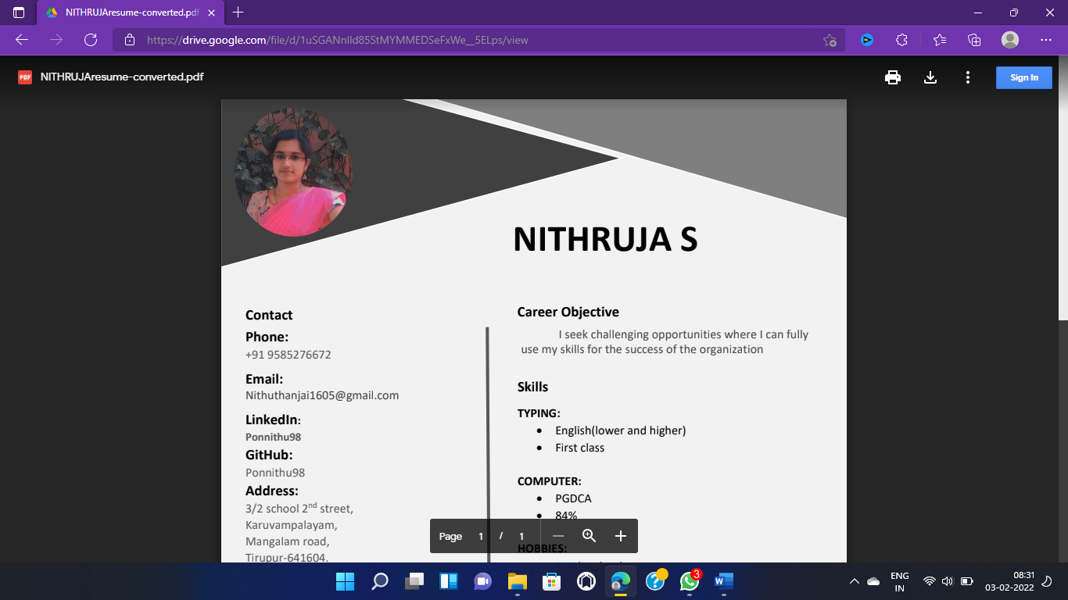

2.3 RESUME PAGE:

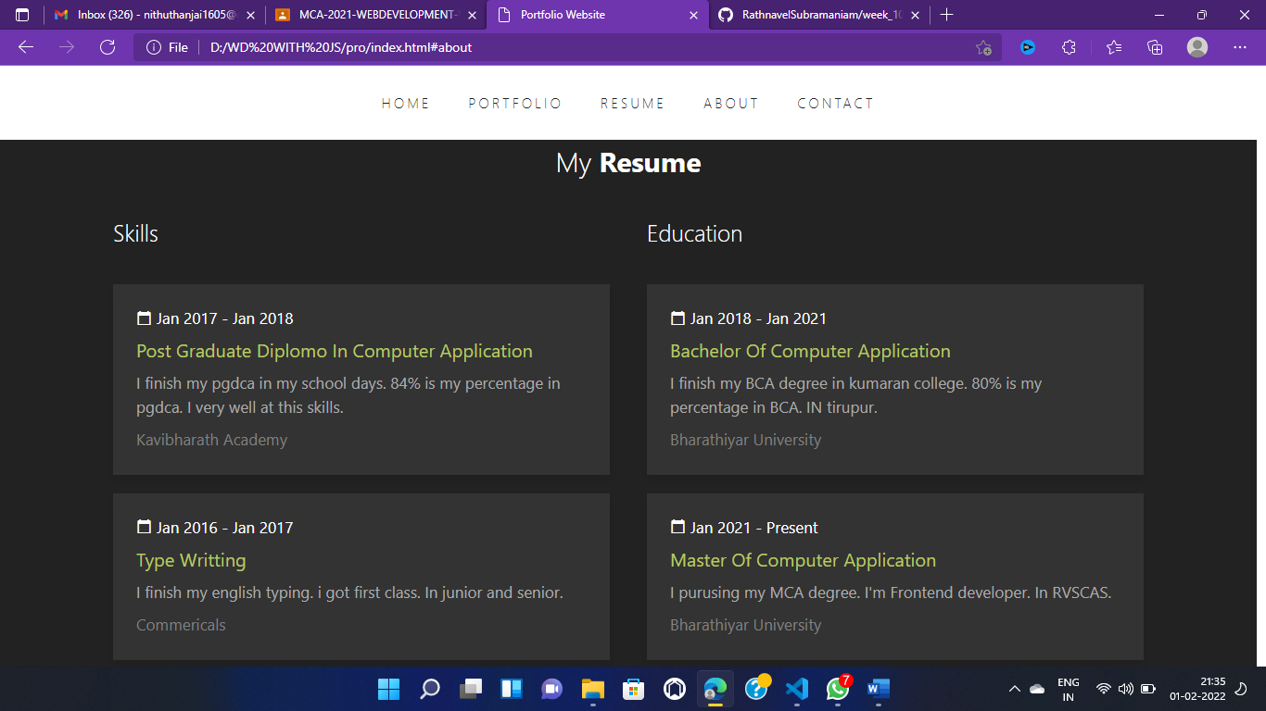

HTML FILE:

 <!-- resume section starts -->

<section class="resume" id="resume">

    <h1 class="heading">my <span>resume</span></h1>

    <div class="col-container">

      <div class="col">

        <h2>Skills</h2>

        <div class="box">

          <span><i class="material-icons"> calendar_today </i> Jan 2017 - Jan 2018</span>

          <h3>post graduate diplomo in computer application</h3>

          <p>

            I finish my pgdca in my school days. 84% is my percentage in pgdca.

            I very well at this skills.

          </p>

          <p class="university">Kavibharath Academy </p>

        </div>

        <div class="box">

          <span><i class="material-icons"> calendar_today </i> Jan 2016 - Jan 2017</span>

          <h3>Type writting</h3>

          <p>

            I finish my english typing. i got first class.

            In junior and senior.

          </p>

          <p class="university">commericals</p>

        </div>

      </div>

      <div class="col">

        <h2>education</h2>

        <div class="box">

          <span><i class="material-icons"> calendar_today </i> Jan 2018 - Jan 2021</span>

          <h3>Bachelor of computer application</h3>

          <p>

          I finish my BCA degree in kumaran college. 80% is my percentage in BCA.

          IN tirupur.

          </p>

          <p class="university">Bharathiyar university</p>

        </div>

        <div class="box">

          <span><i class="material-icons"> calendar_today </i> Jan 2021 - present</span>

          <h3>Master of computer application</h3>

          <p>

          I purusing my MCA degree. I'm Frontend developer.

          In RVSCAS.

          </p>

          <p class="university">Bharathiyar university</p>

        </div>

      </div>

    </div>

  </section>

  <!-- resume section ends -->

CSS:

 /* resume */

.resume .col-container .col .box {

    background-color: var(--light-bg);

    padding: 2.5rem;

    margin: 2rem 0;

    box-shadow: var(--box-shadow);

  }

  .resume .col-container {

    display: grid;

    grid-template-columns: repeat(auto-fit, minmax(30rem, 1fr));

    gap: 4rem;

  }

  .resume .col-container .col h2 {

    font-size: 2.5rem;

    color: var(--white);

    font-weight: 200;

    padding-bottom: 2rem;

  }

  .resume .col-container .col .box span {

    color: var(--white);

    font-size: 1.7rem;

    display: flex;

    align-items: center;

  }

  .resume .col-container .col .box span i {

    padding-right: 0.5rem;

    font-size: 1.7rem;

  }

  .resume .col-container .col .box h3 {

    color: var(--yellow);

    font-size: 2rem;

    margin-top: 1rem;

    font-weight: 400;

  }

  .resume .col-container .col .box p {

    font-size: 1.7rem;

    color: var(--dark-gray);

    margin-top: 1rem;

    line-height: 1.5;

    text-transform: none;

  }

  .resume .col-container .col .box .university {

    color: var(--light-gray);

    text-transform: capitalize;

  }

  /* resume */

2.4 CONTACT PAGE:

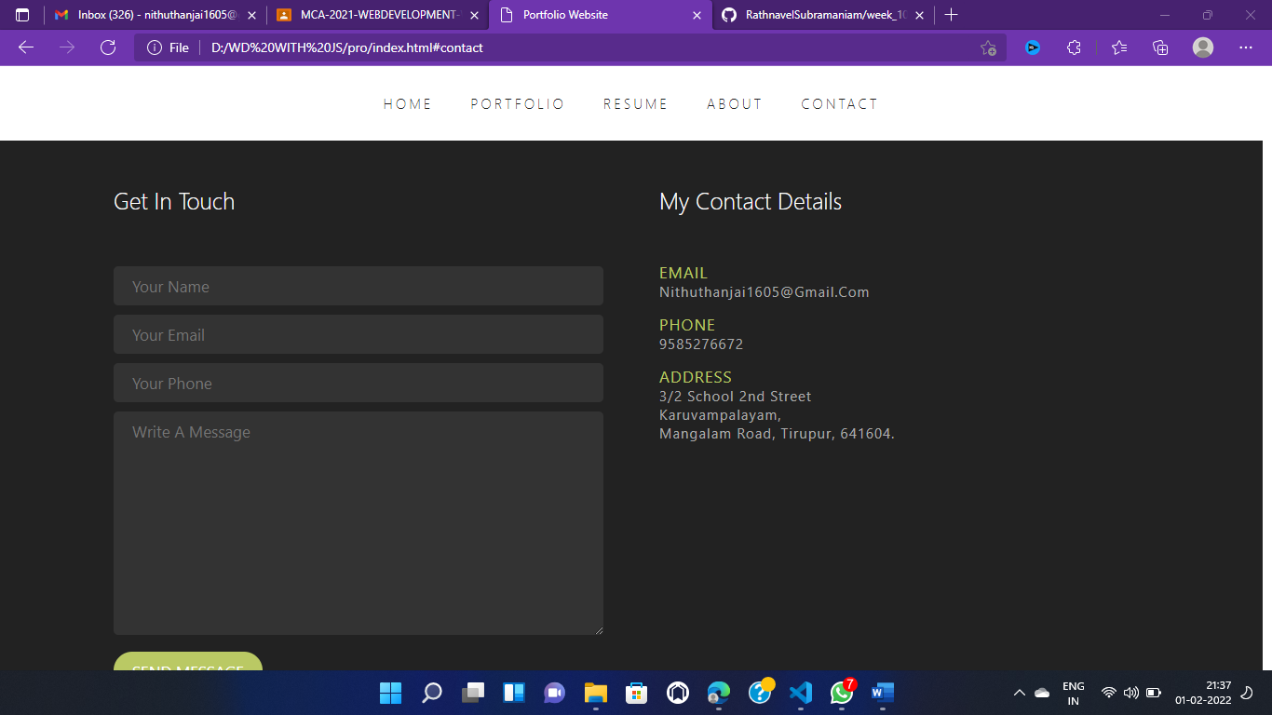

HTML FILE:

<!-- contact section starts -->

<section class="contact" id="contact">

  <h1 class="heading">get <span>in touch</span></h1>

  <div class="col-container">

    <div class="col">

      <h2>get in touch</h2>

      <input type="text" placeholder="your name" />

      <input type="email" placeholder="your email" />

      <input type="text" placeholder="your phone" />

      <textarea name="" placeholder="write a message" id="" cols="30" rows="10"></textarea>

      <a href="#" class="btn">send message</a>

    </div>

    <div class="col">

      <h2>my contact details</h2>

      <p>email</p>

      <span>nithuthanjai1605@gmail.com</span>

      <br />

      <br />

      <p>phone</p>

      <span>9585276672</span>

      <br />

      <br />

      <p>address</p>

      <span>

        3/2 school 2nd street <br />

        karuvampalayam, <br />

        mangalam road,

        tirupur,

        641604.

      </span>

    </div>

  </div>

</section>

<!-- contact section ends -->

CSS FILE:

/* contact */

.contact .col-container {

  display: grid;

  grid-template-columns: repeat(auto-fit, minmax(25rem, 1fr));

  gap: 6rem;

}

.contact .col-container .col h2 {

  font-size: 2.5rem;

  color: var(--white);

  font-weight: 200;

  padding-bottom: 5rem;

}

.contact .col-container .col input,

.contact .col-container .col textarea {

  background-color: var(--light-bg);

  width: 100%;

  padding: 1rem 2rem;

  border-radius: 0.5rem;

  font-size: 1.7rem;

  color: var(--dark-gray);

  margin: 0.5rem 0;

  resize: vertical;

}

.contact .col-container .col p {

  font-size: 1.7rem;

  color: var(--yellow);

  text-transform: uppercase;

  letter-spacing: 0.1rem;

}

.contact .col-container .col span {

  font-size: 1.5rem;

  color: var(--dark-gray);

  letter-spacing: 0.1rem;

}

/* contact */

2.5 FOOTER PAGE:

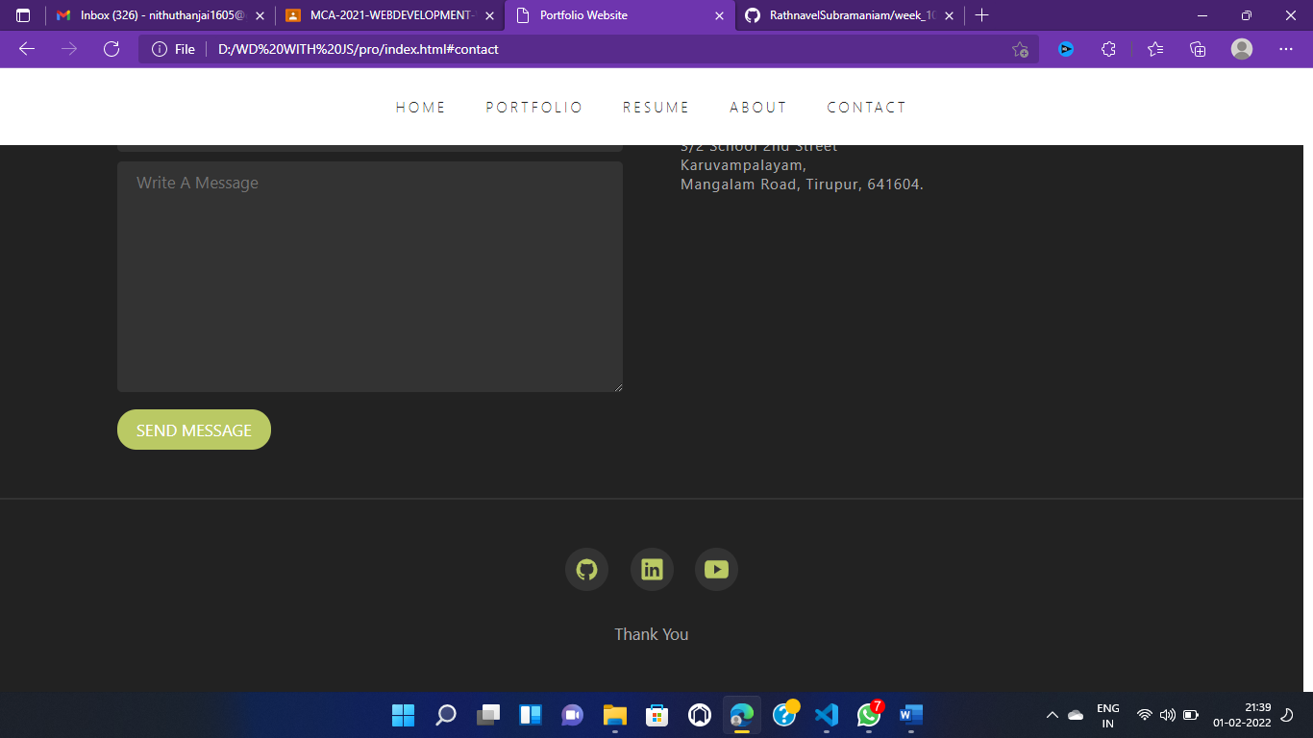

HTML FILE:

<!-- footer section starts -->

<section class="footer" id="footer">

  <div class="socials">

   <a href="https://github.com/orgs/RathnavelSubramaniam/teams/fullstack-javascript-mca-2021"> <ion-icon name="logo-github"></ion-icon></a>

   <a href="https://www.linkedin.com/feed/"><ion-icon name="logo-linkedin"></ion-icon></a>

    <ion-icon name="logo-youtube"></ion-icon>

  </div>

  <p>Thank you </p>

</section>

<!-- footer section ends -->

  </body>

</html>

CSS:

/* footer */

.footer {

  border-top: 0.2rem solid var(--light-bg);

  text-align: center;

}

.footer .socials ion-icon {

  font-size: 2.5rem;

  color: var(--yellow);

  background-color: var(--light-bg);

  border-radius: 50%;

  padding: 1rem;

  margin: 0 1rem;

  cursor: pointer;

}

.footer p {

  font-size: 1.7rem;

  color: var(--dark-gray);

  margin-top: 3rem;

}

.socials ion-icon {

  font-size: 2.5rem;

  color: var(--yellow);

  background-color: var(--light-bg);

  border-radius: 50%;

  padding: 1rem;

  margin: 0 1rem;

  cursor: pointer;

}

/* footer */

2.6: script:

document.onscroll = () => {

  if (window.scrollY > 0) {

    document.querySelector('.header').classList.add('active');

  } else {

    document.querySelector('.header').classList.remove('active');

  }

};

document.onload = () => {

  if (window.scrollY > 0) {

    document.querySelector('.header').classList.add('active');

  } else {

    document.querySelector('.header').classList.remove('active');

  }

};

const navbar = document.querySelector('.header .navbar');

const menuButton = document.querySelector('.header .menu');

menuButton.addEventListener('click', () => {

  navbar.classList.toggle('show');

});

document.onscroll = () => {

  navbar.classList.remove('show');

  if (window.scrollY > 0) {

    document.querySelector('.header').classList.add('active');

  } else {

    document.querySelector('.header').classList.remove('active');

  }

};

document.onload = () => {

  if (window.scrollY > 0) {

    document.querySelector('.header').classList.add('active');

  } else {

    document.querySelector('.header').classList.remove('active');

  }

};

**CHAPTER 3:**

**PAGES AND NAVIGATION:**

**3.1 Landing page:**

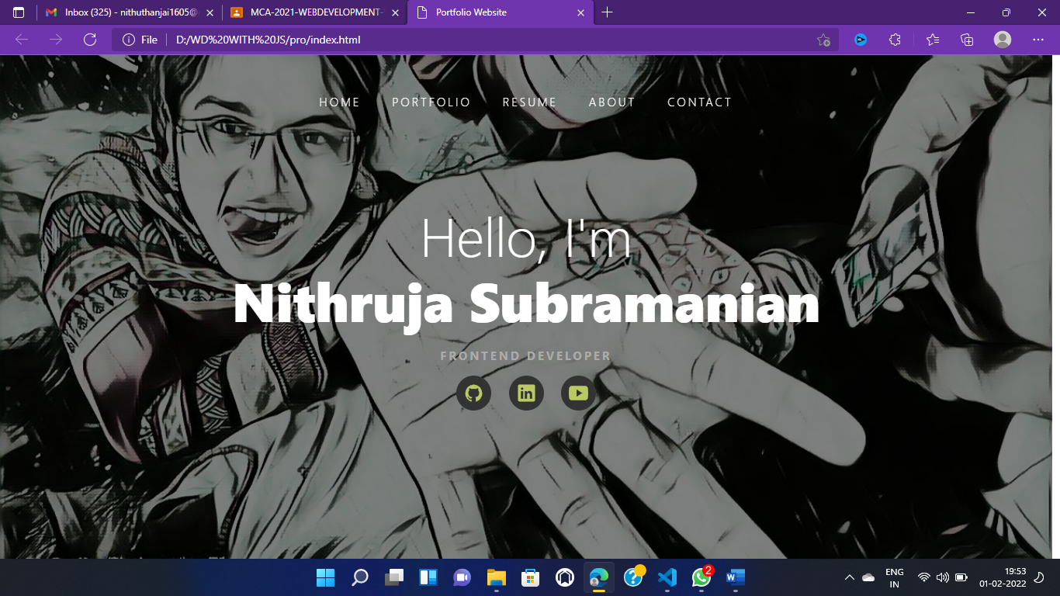

HTML FILE:

 <!-- header section starts -->

<header class="header">

    <a><i class="menu material-icons"> menu </i></a>

    <nav class="navbar">

      <a href="#">home</a>

      <a href="#portfolio">portfolio</a>

      <a href="#resume">resume</a>

      <a href="#about">about</a>

      <a href="#contact">contact</a>

    </nav>

  </header>

  <!-- header section ends -->

    <!-- home section starts -->

<section class="home" id="home">

    <h1 class="hero-text">

      hello, i'm <br />

      <span>Nithruja subramanian</span>

    </h1>

   <h3> <p>Frontend developer</p><br></h3>

    <div class="socials">

      <a href="https://github.com/orgs/RathnavelSubramaniam/teams/fullstack-javascript-mca-2021"><ion-icon name="logo-github"></ion-icon></a>

     <a href="https://www.linkedin.com/feed/"> <ion-icon name="logo-linkedin"></ion-icon></a>

      <ion-icon name="logo-youtube"></ion-icon>

    </div>

  </section>

  <!-- home section ends -->

CSS FILE:

* home */

.home {

    height: 100vh;

    background: linear-gradient(rgba(0, 0, 0, 0.5), rgba(0, 0, 0, 0.5)), url('images/7.jpeg');

    filter: var(--yellow);

    background-size: cover;

    background-position: center;

    background-attachment: fixed;

    display: flex;

    align-items: center;

    justify-content: center;

    flex-direction: column;

    text-align: center;

  }

  .home .hero-text {

    font-size: 7rem;

    color: var(--white);

    font-weight: 200;

    line-height: 1.2;

  }

  .home .hero-text span {

    font-weight: 800;

  }

  .home p {

    color: var(--dark-gray);

    font-size: 1.5rem;

    margin-top: 2rem;

    text-transform: uppercase;

    letter-spacing: 0.3rem;

  }

  /* home */

  /* header */

.header {

    position: fixed;

    top: 0;

    left: 0;

    right: 0;

    padding: 5rem 9%;

    z-index: 100;

  }

  .header.active {

    background-color: var(--white);

    padding: 3rem 9%;

  }

  .header.active .navbar a {

    color: var(--dark-bg);

  }

  .header.active .navbar a:hover {

    color: var(--yellow);

  }

  .header.active .menu {

    color: var(--dark-bg);

  }

  .header .navbar {

    display: flex;

    align-items: center;

    justify-content: center;

  }

  .header .navbar a {

    font-size: 1.5rem;

    color: var(--white);

    padding: 0 2rem;

    letter-spacing: 0.3rem;

    font-weight: 300;

    text-transform: uppercase;

  }

  .header .menu {

    font-size: 2.5rem;

    color: var(--white);

    cursor: pointer;

    text-align: left;

    display: none;

  }

  /* header */

3.2 PROJECT PAGE:

PROJECTS:

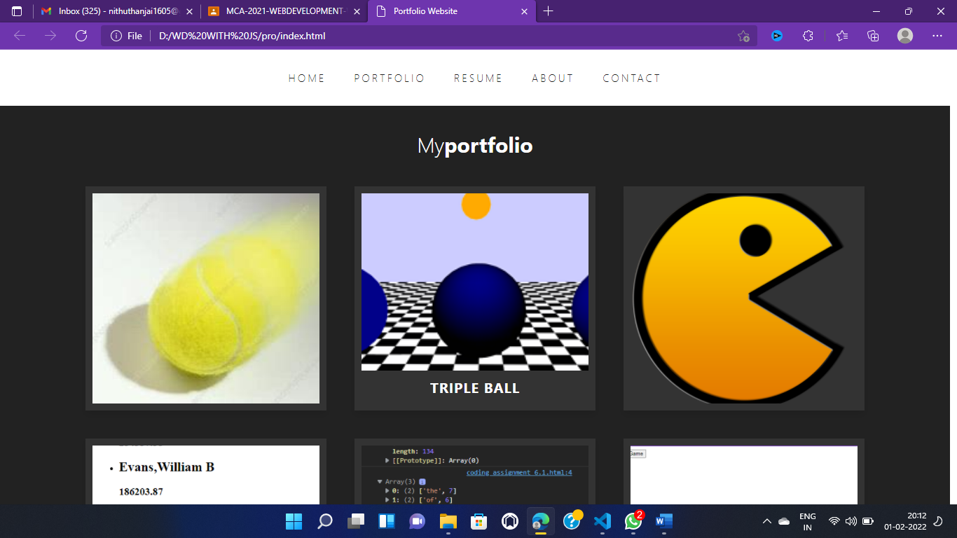

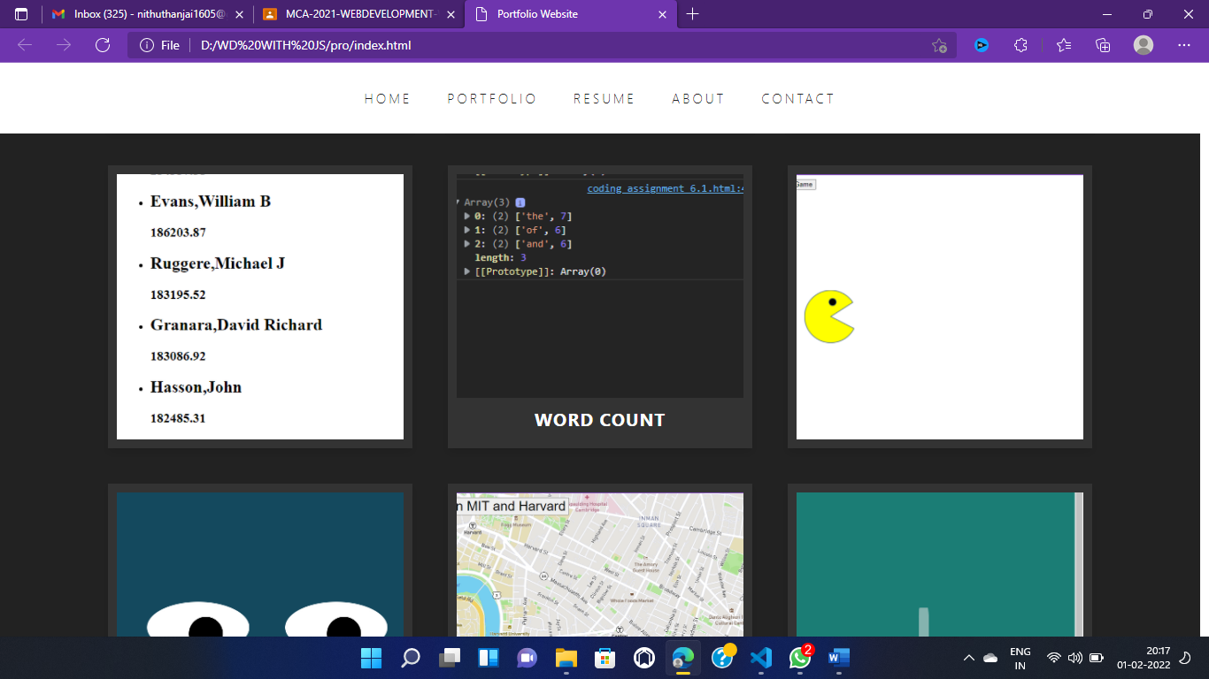

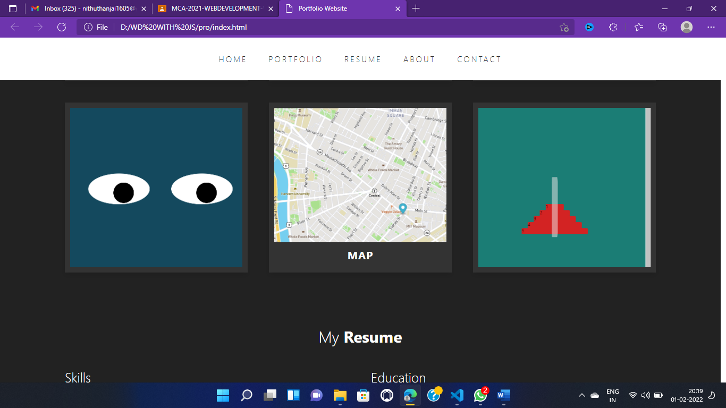

HTML FILE:

<!-- portfolio section starts -->

<section class="portfolio" id="portfolio">

    <h1 class="heading">My<span>portfolio</span></h1>

    <div class="box-container">

      <div class="box">

        <div class="image">

          <img src="images/ball 1.jpg" alt="" />

          <div class="content">

            <a href="https://ponnithu98.github.io/week2/"><h2>BALL MOVEMENT</a><br>

            <a href="https://github.com/RathnavelSubramaniam/week_2_computational_thinking_assignement-Ponnithu98">click</h2></a>

          </div>

        </div>

      </div>

      <div class="box">

        <div class="image">

          <img src="images/triple.png" alt="" />

          <div class="content">

           <a href="https://ponnithu98.github.io/week3/"> <h2>TRIPLE BALL</a><br>

           <a href="https://github.com/RathnavelSubramaniam/week_3_mental_model-of-computing_operations-Ponnithu98">click</h2></a>

          </div>

        </div>

      </div>

      <div class="box">

        <div class="image">

          <img src="images/pacman.png" alt="" />

          <div class="content">

            <a href="https://ponnithu98.github.io/Week4-Assignment/"><h2>PACMAN</a><br>

            <a href="https://github.com/RathnavelSubramaniam/week-4_coding_assignment-Ponnithu98">click</h2></a>

          </div>

        </div>

      </div>

      <div class="box">

        <div class="image">

          <img src="images/boston.png" alt="" />

          <div class="content">

            <a href="https://ponnithu98.github.io/WEEK_5/"><h2>Boston</a><br>

            <a href="https://github.com/RathnavelSubramaniam/week_5_coding_assignment-Ponnithu98">click</h2></a>

          </div>

        </div>

      </div>

      <div class="box">

        <div class="image">

          <img src="images/word.png" alt="" />

          <div class="content">

           <a href="https://ponnithu98.github.io/WEEK_6/"> <h2>WORD COUNT</a><br>

           <a href="https://github.com/RathnavelSubramaniam/week-6_coding_assignment-Ponnithu98">click</h2></a>

          </div>

        </div>

      </div>

      <div class="box">

        <div class="image">

          <img src="images/pacmen.png" alt="" />

          <div class="content">

           <a href="https://ponnithu98.github.io/WEEK--7/"> <h2>Pacmen</a><br>

           <a href="https://github.com/RathnavelSubramaniam/coding_assignment_7_1-Ponnithu98">click</h2></a>

          </div>

        </div>

      </div>

      <div class="box">

        <div class="image">

          <img src="images/eye.png" alt="" />

          <div class="content">

            <a href="https://ponnithu98.github.io/WEEK8/"><h2>Eye</a><br>

            <a href="https://github.com/RathnavelSubramaniam/coding_assignment_8_1-Ponnithu98">click</h2></a>

          </div>

        </div>

      </div>

      <div class="box">

        <div class="image">

          <img src="images/map.png" alt="" />

          <div class="content">

            <a href="https://ponnithu98.github.io/week-9/"><h2>Map</a><br>

            <a href="https://github.com/RathnavelSubramaniam/week_9_coding_assignment-Ponnithu98">click</h2></a>

          </div>

        </div>

      </div>

      <div class="box">

        <div class="image">

          <img src="images/tower.png" alt="" />

          <div class="content">

            <a href="https://ponnithu98.github.io/week-10/"><h2>Tower</a><br.

            <a href="https://github.com/RathnavelSubramaniam/week_10_coding_activity_assignment-Ponnithu98">click</h2></a>

          </div>

        </div>

      </div>

    </div>

  </section>

  <!-- portfolio section ends -->

CSS:

/* portfolio */

.portfolio .box-container .box .image {

    height: 30rem;

    overflow: hidden;

    position: relative;

  }

  .portfolio .box-container .box .image img {

    width: 100%;

    height: 100%;

    object-fit: cover;

  }

  .portfolio .box-container {

    display: grid;

    grid-template-columns: repeat(auto-fit, minmax(30rem, 1fr));

    gap: 4rem;

  }

  .portfolio .box-container .box {

    background-color: var(--light-bg);

    padding: 1rem;

    box-shadow: var(--box-shadow);

  }

  .portfolio .box-container .box:hover .image img {

    transform: scale(1.2);

  }

  .portfolio .box-container .box .image .content {

    position: absolute;

    left: 0;

    bottom: 0;

    right: 0;

    background-color: var(--light-bg);

    padding: 1rem;

    display: flex;

    align-items: center;

    justify-content: center;

    transform: translateY(100%);

  }

  .portfolio .box-container .box .image .content h2 {

    font-size: 2rem;

    color: var(--white);

    letter-spacing: 0.1rem;

    text-transform: uppercase;

  }

  .portfolio .box-container .box .image .content h2 {

    font-size: 2rem;

    color: var(--white);

    letter-spacing: 0.1rem;

    text-transform: uppercase;

  }

  .portfolio .box-container .box:hover .image .content {

    transform: translateY(0);

  }

  /* portfolio */

3.3 Navigation Bar:

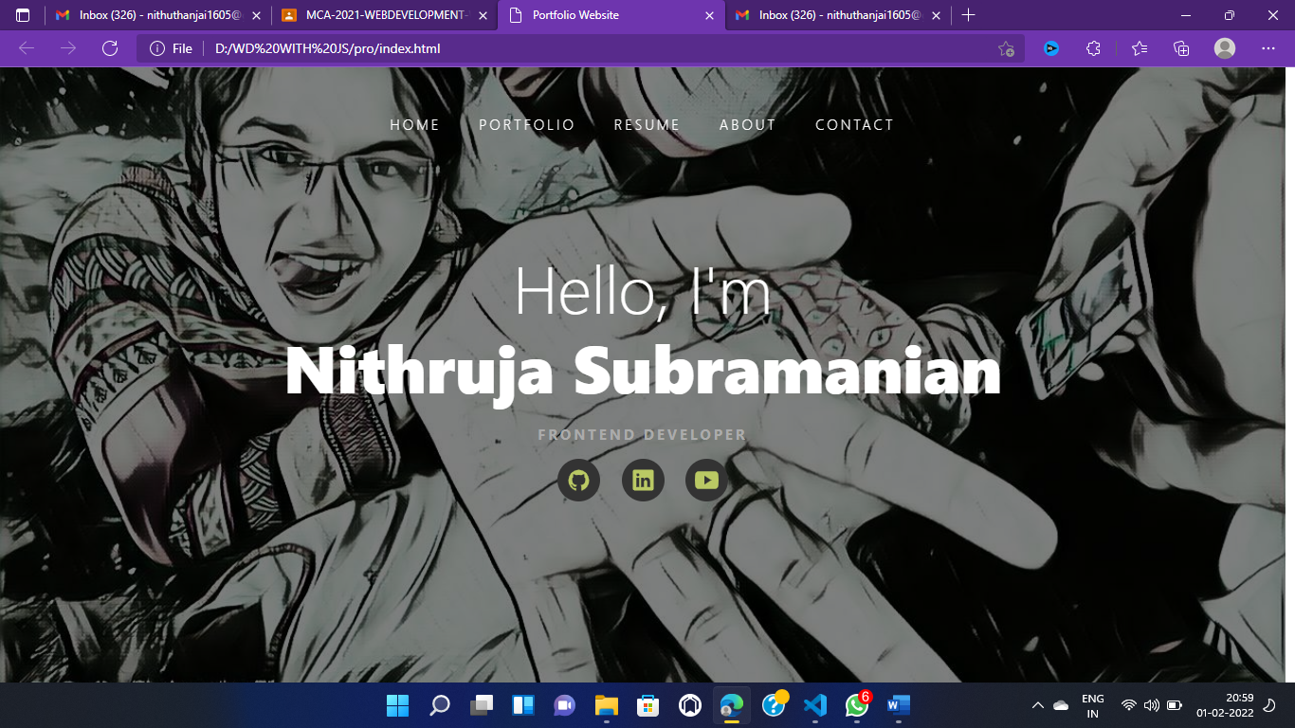

HTML FILE:

<!-- header section starts -->

<header class="header">

    <a><i class="menu material-icons"> menu </i></a>

    <nav class="navbar">

      <a href="#">home</a>

      <a href="#portfolio">portfolio</a>

    <a href="#resume">resume</a>

      <a href="#about">about</a>

      <a href="#contact">contact</a>

    </nav></header>

  <!-- header section ends -->

CSS FILE:

  .header .navbar {

    display: flex;

    align-items: center;

    justify-content: center;

  }

  .header .navbar a {

    font-size: 1.5rem;

    color: var(--white);

    padding: 0 2rem;

    letter-spacing: 0.3rem;

    font-weight: 300;

    text-transform: uppercase;

  }

**CHAPTER 4:**

**STYLES LINK:**

**4.1 styles(font color images):**

<!DOCTYPE html>

<html lang="en">

  <head>

    <meta charset="UTF-8" />

    <meta http-equiv="X-UA-Compatible" content="IE=edge" />

    <meta name="viewport" content="width=device-width, initial-scale=1.0" />

    <title>Portfolio Website</title>

    <!-- google font icons -->

    <link href="https://fonts.googleapis.com/icon?family=Material+Icons" rel="stylesheet" />

    <!-- local css file -->

    <link rel="stylesheet" href="styles.css" />

  </head>

  <body>

    <!-- ion icons import -->

    <script

      type="module"

 src="https://unpkg.com/ionicons@5.5.2/dist/ionicons/ionicons.esm.js”> ></script>

    <script nomodule src="https://unpkg.com/ionicons@5.5.2/dist/ionicons/ionicons.js"></script>

    <!-- local js file -->

    <script src="script.js"></script>

4.2 styles:

/* media queries */

@media (max-width: 1200px) {

  .header {

    padding: 3rem 2rem;

  }

  .header.active {

    padding: 2rem;

  }

**CHAPTER 5:**

**WEBSITE INCLUDE THE FOLLOWING INFORMATION**

5.1 Project links to Github:







Links:

<https://ponnithu98.github.io/week2/>

<https://ponnithu98.github.io/week3/>

<https://ponnithu98.github.io/Week4-Assignment/>

<https://ponnithu98.github.io/WEEK_5/>

<https://ponnithu98.github.io/WEEK_6/>

<https://ponnithu98.github.io/WEEK--7/>

<https://ponnithu98.github.io/WEEK--8/>

<https://ponnithu98.github.io/week-9/>

<https://ponnithu98.github.io/week-10/>

**5.2** **Project Description :**

* In my web page , I’ve described about myself and my skills.
* I have used Frontend as HTML, CSS and Backend as javascript.
* In the landing page I have uploaded my introduction youtube video.
* In Project section,that I mentioned my project what I have done.
* In Contact section, I used my github,linkedin,email id,facebook and my contact number and also I upload my resume for further reference.
* I used boostrap l for title logo and grid layout

https://ponnithu98.github.io/WEEK--7/

**CHAPTER 6**

**BOOSTRAP**

**6.1 use boostrap:**

    <link href="https://fonts.googleapis.com/icon?family=Material+Icons" rel="stylesheet" />

    <link rel="stylesheet" href="styles.css" />

  </head>

  <body><script

      type="module"

  src="https://unpkg.com/ionicons@5.5.2/dist/ionicons/ionicons.esm.js"

    ></script>

    <script nomodule src="https://unpkg.com/ionicons@5.5.2/dist/ionicons/ionicons.js"></script>

**CHAPTER 7:**

**PROJECT README:**

7 Title Description:

Project 1:

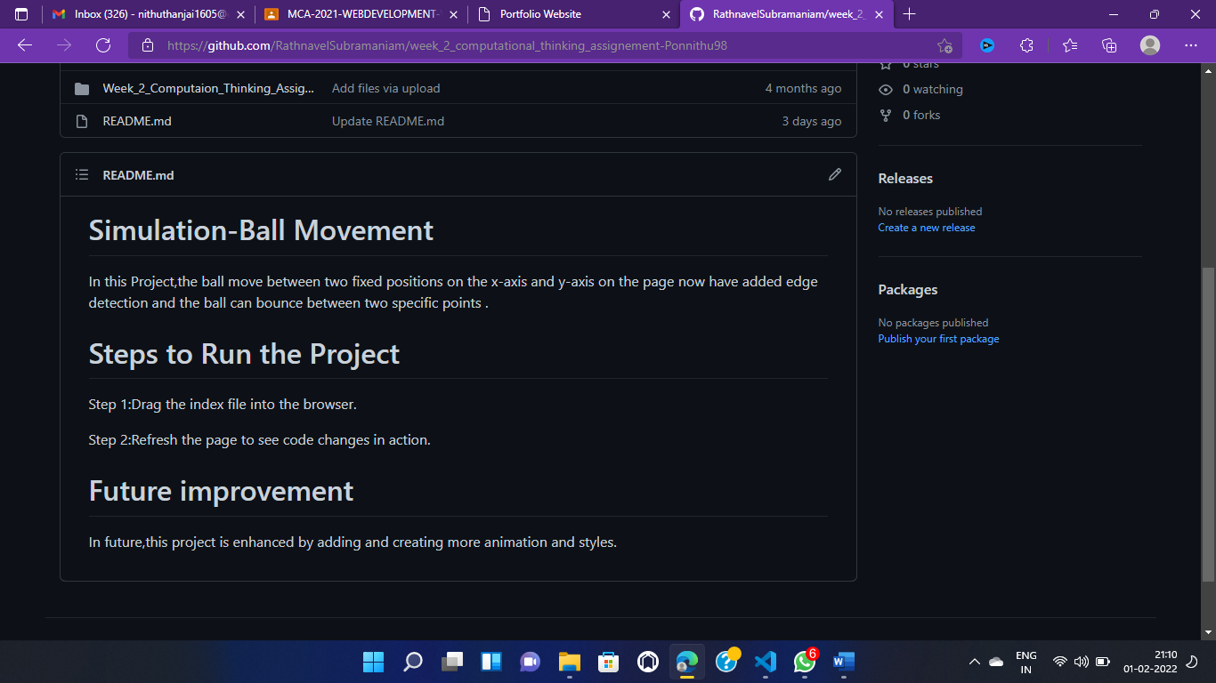

Project 2:

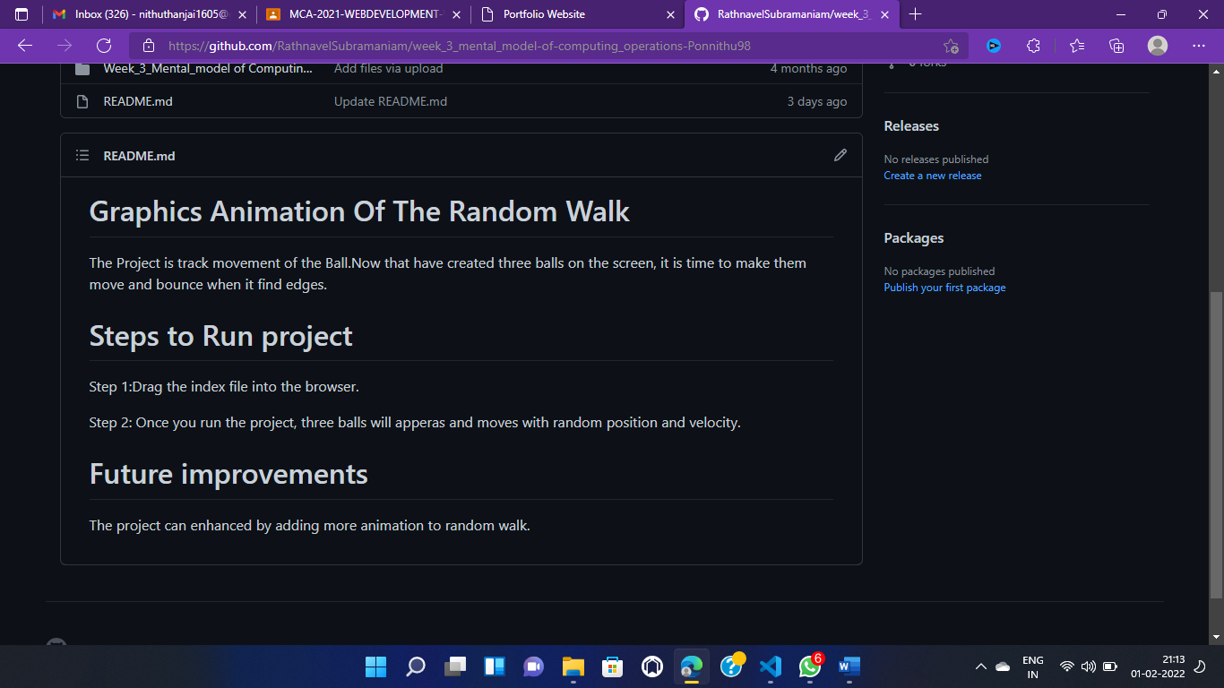

Project 3:

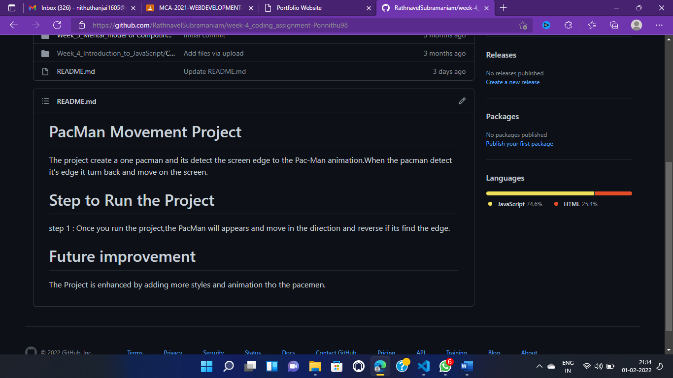

Project 4:

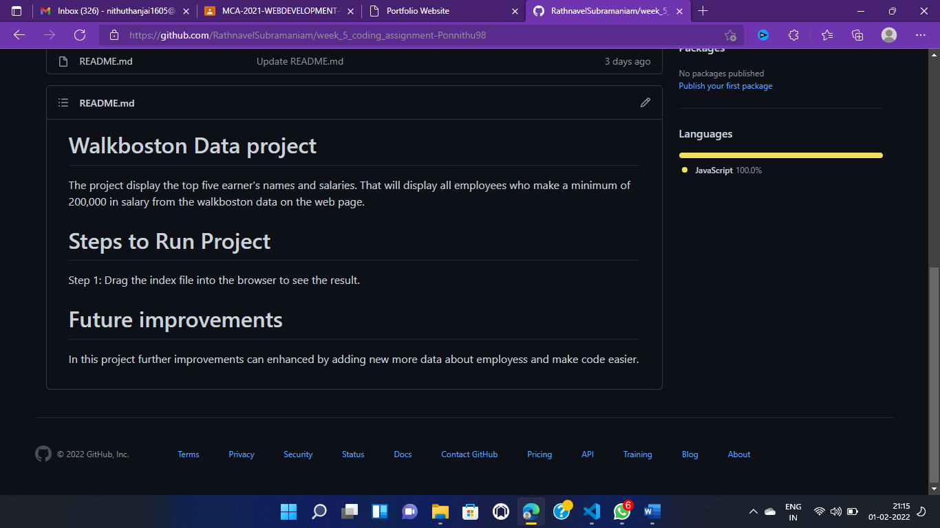

Project 5:

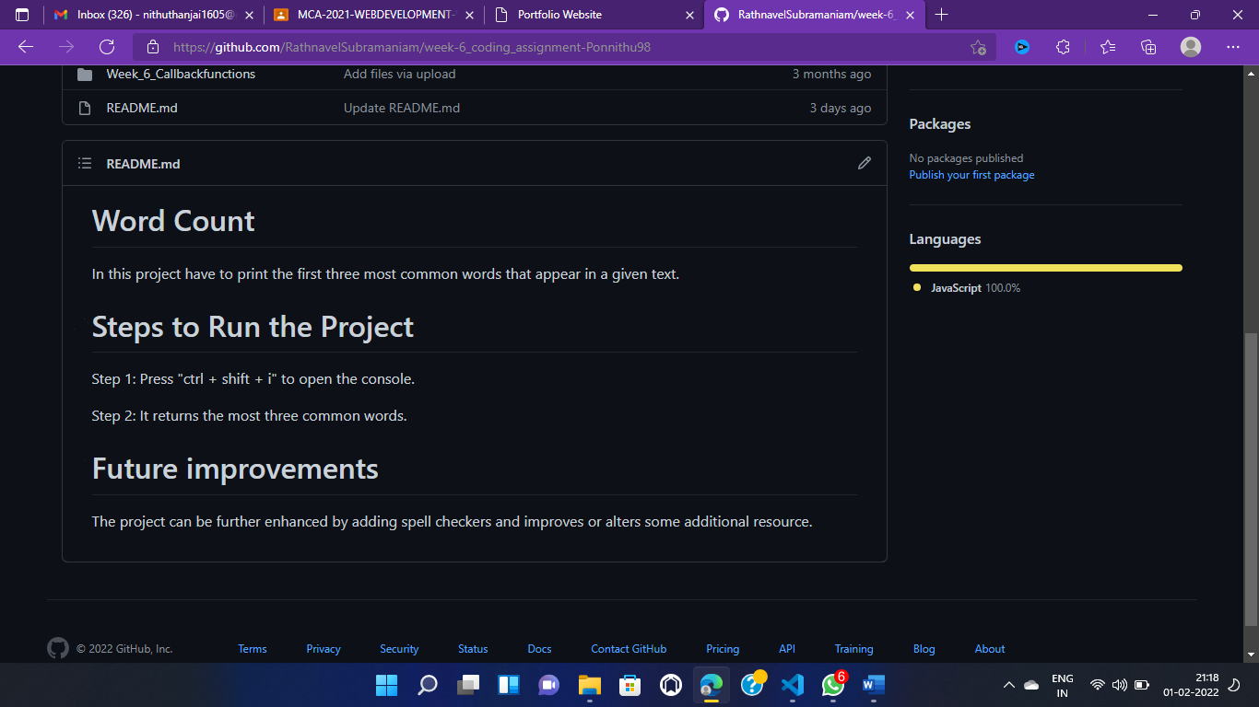

Project 6:

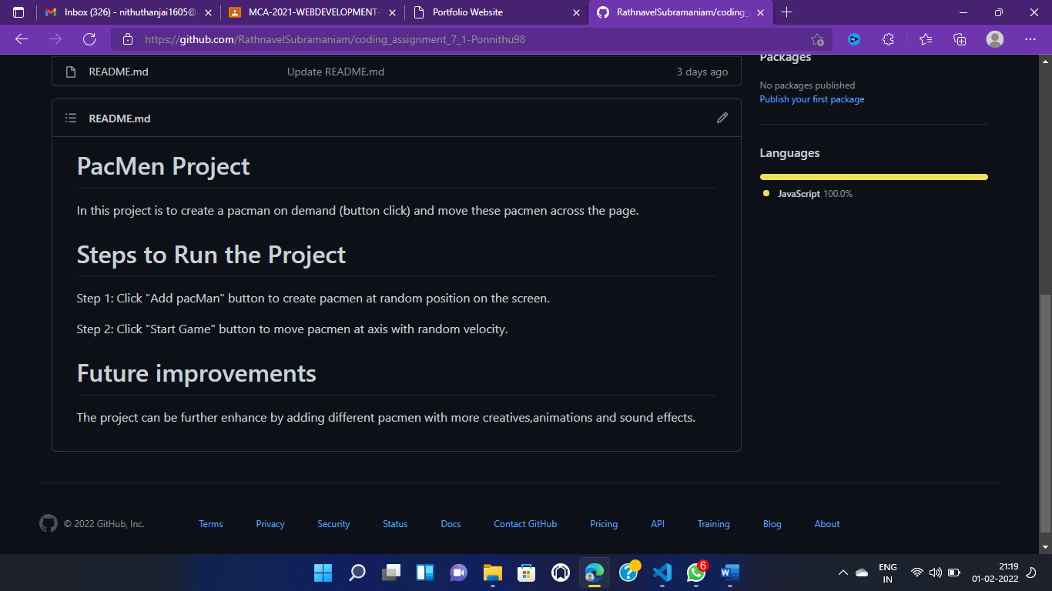

Project 7:

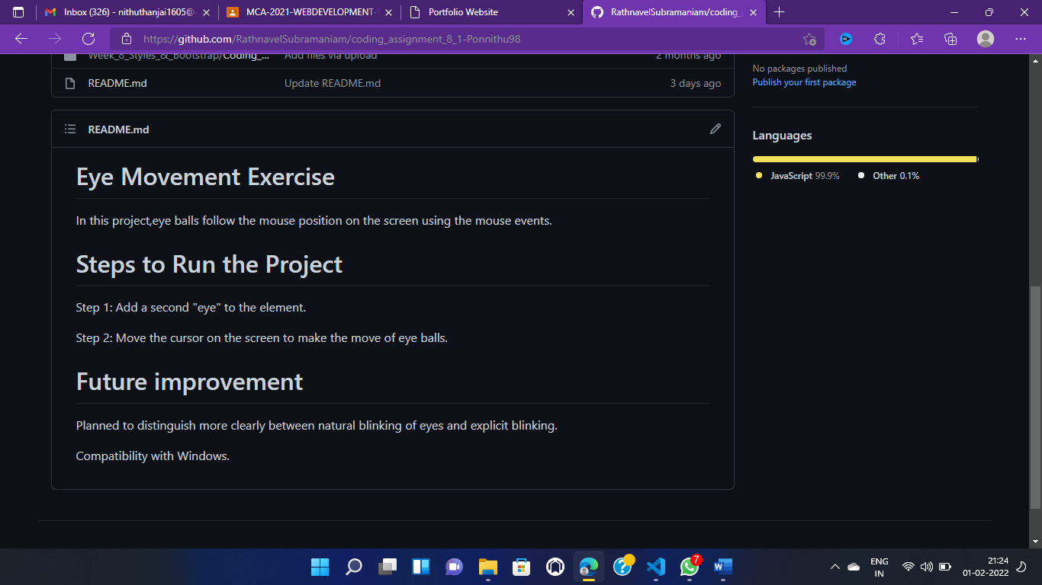

Project 8:

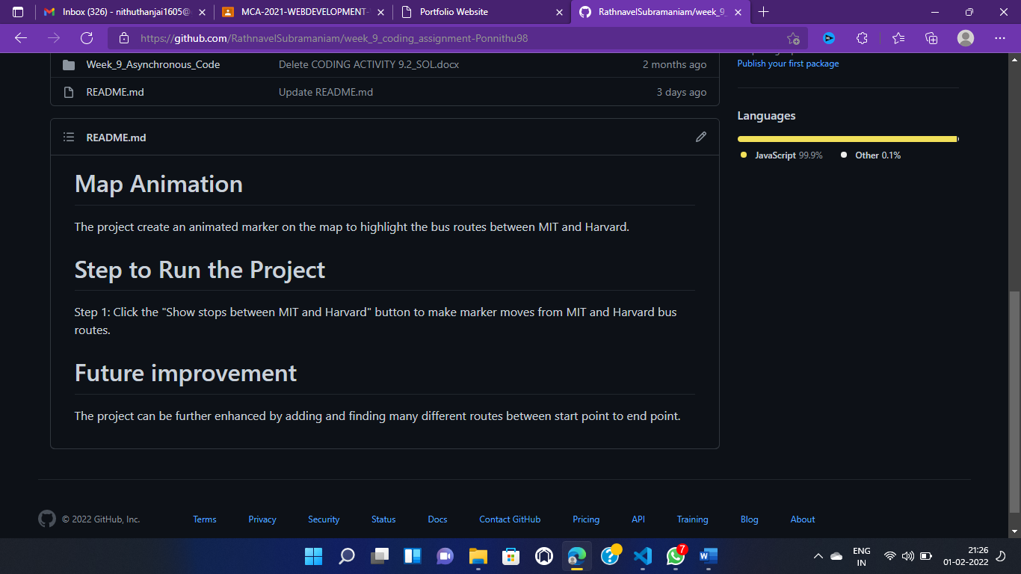

Project 9:

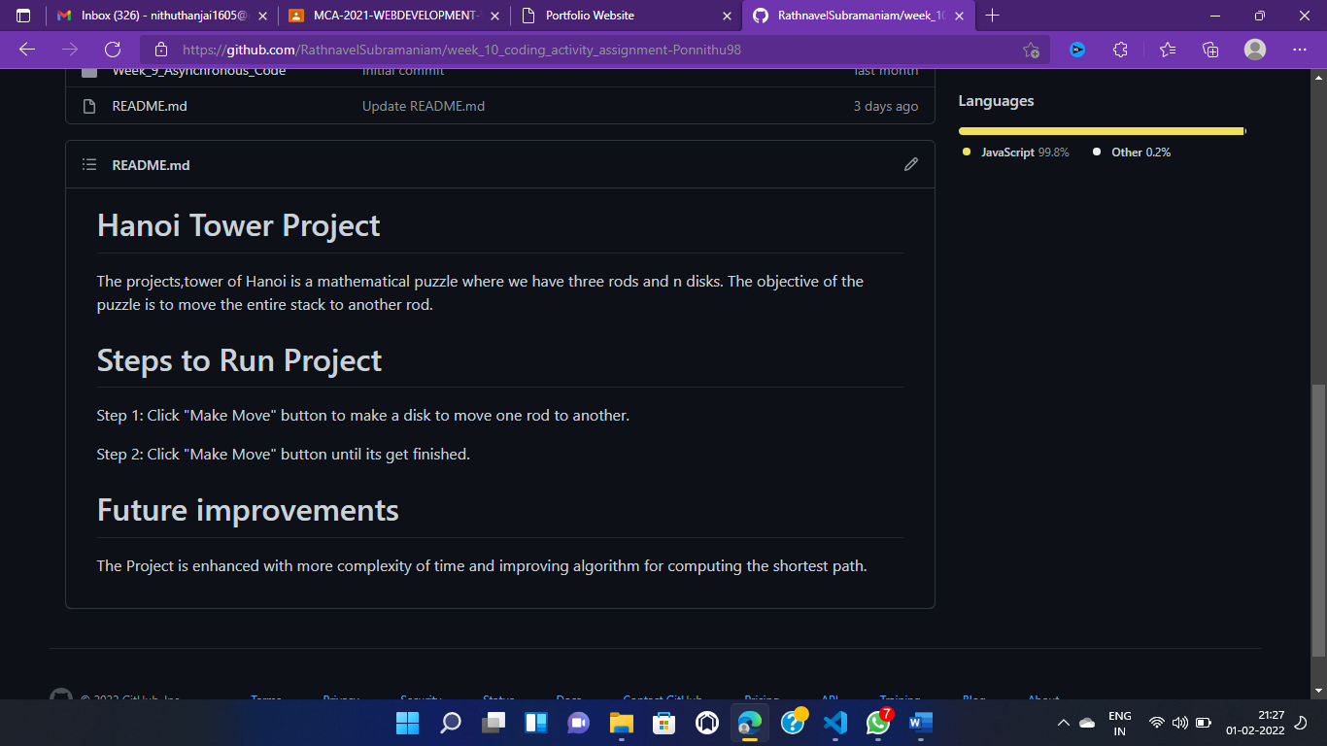

**CHAPTER 8:**

**FILE STRUCTURE**:

8 GITHUB FILE STRUCTURE:

